Muttable VS Imutable Infrastructure

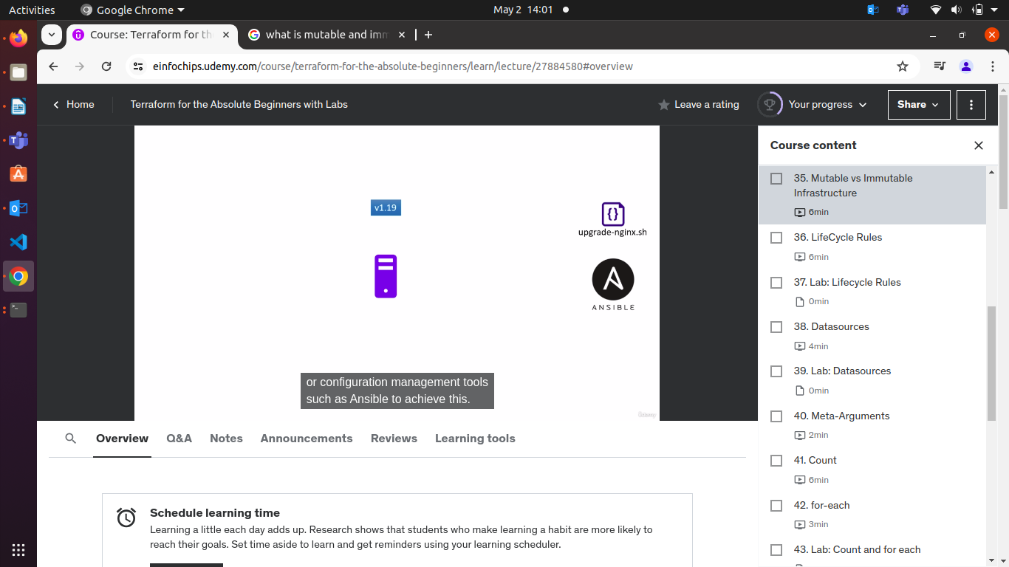
When you update your config file after resource has been created.
Terraform will destroy the resources and recreate it.
Why terraform do this ?

Example

You have a nginx server & version is v1.17.
Your web is hosting on this nginx server.
When you need to update the nginx version from v1.17 to v1.18
You can do this by manually update or using ansible.

For High Availablility
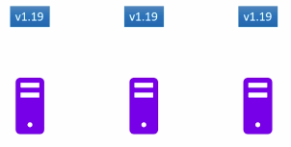
We have a pool of this web server and running same software and code.

So, we have to just update the existing software/web server without affecting the deployed or existing infrastructure.
This is done by automation updation using ansible.

Infrastructure will remain same but, configuration and software ( version ) will be changed.

Immutable Infrastructure
We are replace whole this web server with a new updated varsion of server & delete old web server.

This is called Immutable Infrastructure.
Immutable means unchanged or something that you can not change.
If you tried to update the web server , old web server will be deleted.
If your update web server goes to failed, the old web server will be added and failed update new web server will be removed.

Immutable makes it easier to version the infrastructure and to roll back and roll forward between versions.

Terraform uses this apporach – immutable approach.

Terraform will delete the old resources after you made update in your config file & create a new resource you define in your config file.
If you want the new updated resource to be created first before the old resource is deleted. Or to ignore deletion completly.

This is possible by Lifecycle rules in our resource block.
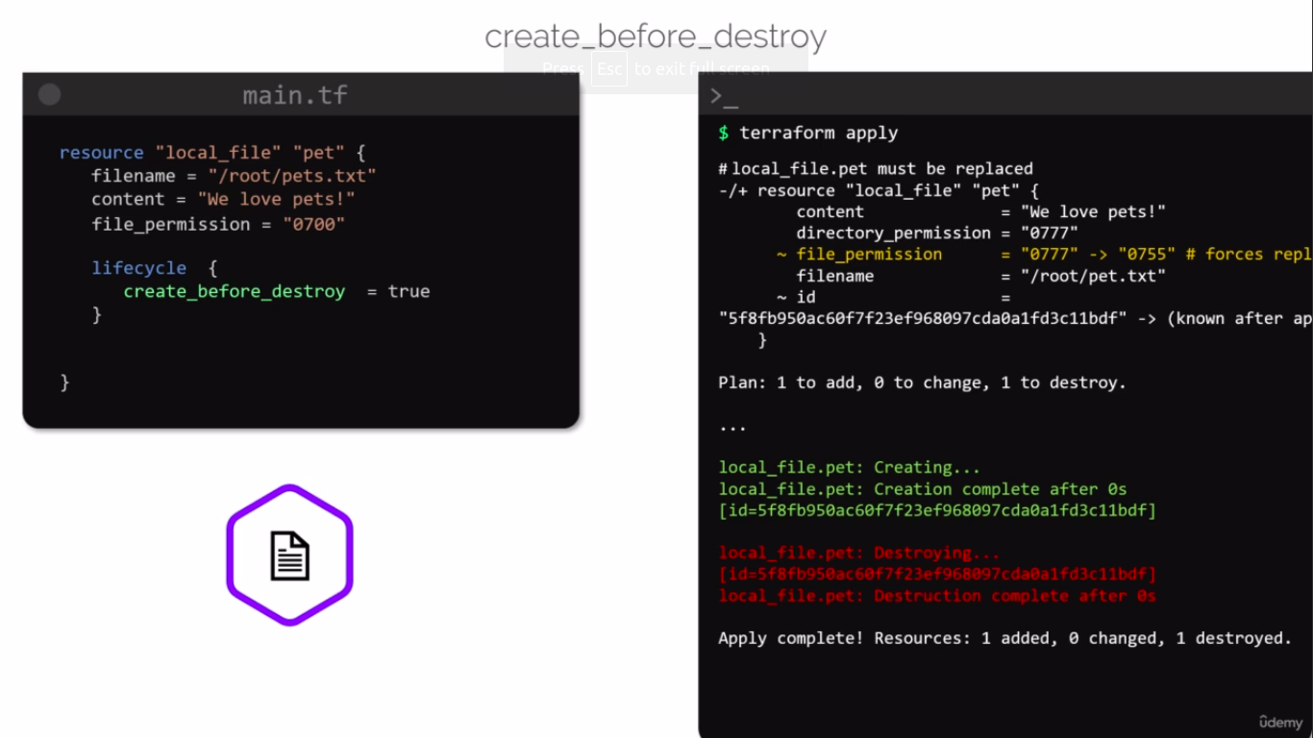
Add lifecycle rule --
lifecycle {
create_before_destroy = true
}

Here, you can see the new updated resources are created fiest in Green Line.

Old resources are destroyed after new updated resources are created in Red line.

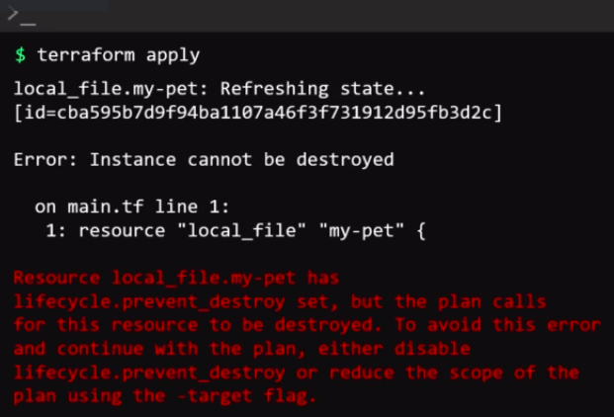
If you want to the older resource should not destroyed or never destroyed or keep it even you created new updated resources.

Add lifecycle rule --
lifecycle {
prevent_destroy = true
}

It will give you error for can not destroy older resources.

Example :MySQL, NGNIX, WordPress, File Systems etc.

The Resources still can be destroyed if you run terraform destroy command.
Even you define LifeCycle run in Resource Block.

So, Be ALERT while run terraform destroy command.

Ignore Changes Rule

If you applied this lifecycle rule in your resource block.
It will prevent a resource from being updated based on a list of attibute that we define within the lifecycle block.
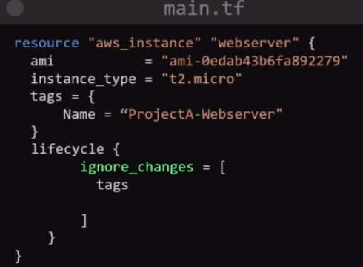
Add lifecycle rule --
lifecycle {
ignore_changes = [
tags, ami
]
}

Example
you have an AWS S3 bucket resource defined in your Terraform configuration, and this bucket's tags are managed outside of Terraform. You want Terraform to manage all other attributes of the bucket, but you don't want it to try to update the tags. You can achieve this using the ignore_changes lifecycle rule.

